ORGANIZATION SKILL DIRECTORY
@CREATIVITY THINK (9483175986/7019689991)

ABSTRACT:
The Organization Skill Directory is a web-based application designed to manage employee skills, endorsements, and analytics within organizations, HR departments, schools, and skill networks. The platform allows users to register their skills, endorse colleagues, and track performance through dashboard reports. Administrators can oversee the skill registry, review endorsements, and generate analytics for decision-making. Built with Django and Django Rest Framework on the backend and React with axios and recharts for the frontend, the system provides a scalable, secure, and interactive platform to manage and visualize skills efficiently..

INTRODUCTION OF THE PROJECT:
Organizations often struggle to maintain an updated record of employee skills and competencies. Manual systems lead to fragmented data, difficulty in tracking endorsements, and lack of actionable analytics. The Organization Skill Directory addresses these challenges by providing a centralized platform where employees can register skills, endorse peers, and access performance dashboards. Administrators gain complete control over skill data, endorsements, and reporting. This system streamlines HR processes, promotes skill development, and supports informed decision-making through analytics..

PROJECT OBJECTIVES:

• Provide a centralized platform to manage employee skills and endorsements
• Enable users to search, register, and update their skills
• Allow endorsements to recognize and validate employee competencies
• Offer dashboards for performance tracking and analytics
• Allow administrators to manage skill registry and verify endorsements
• Support real-time reporting and decision-making with analytics
• Reduce manual tracking and fragmented skill records
• Ensure scalability and secure access for both users and administrators

PROBLEM OF THE STATEMENT:
Organizations often rely on fragmented systems or spreadsheets to track skills, resulting in missing data, lack of verification, and difficulty in analyzing workforce competencies. Employees cannot easily showcase their skills or endorsements, and administrators struggle to maintain accurate records. The Organization Skill Directory provides a centralized, digital solution to manage skills, enable endorsements, and generate actionable insights, thereby improving HR management efficiency and transparency..

MOTIVATION OF THE PROJECT:
• To create a structured system for skill management and employee recognition
• To replace manual and fragmented skill tracking
• To enhance transparency and accountability in endorsements
• To provide an intuitive interface for users to register skills and track progress
• To empower administrators with dashboards for workforce insights
• To encourage skill development and professional growth
• To support HR decision-making with real-time analytics

BLOCK DAIGRAM OF PROJECT:

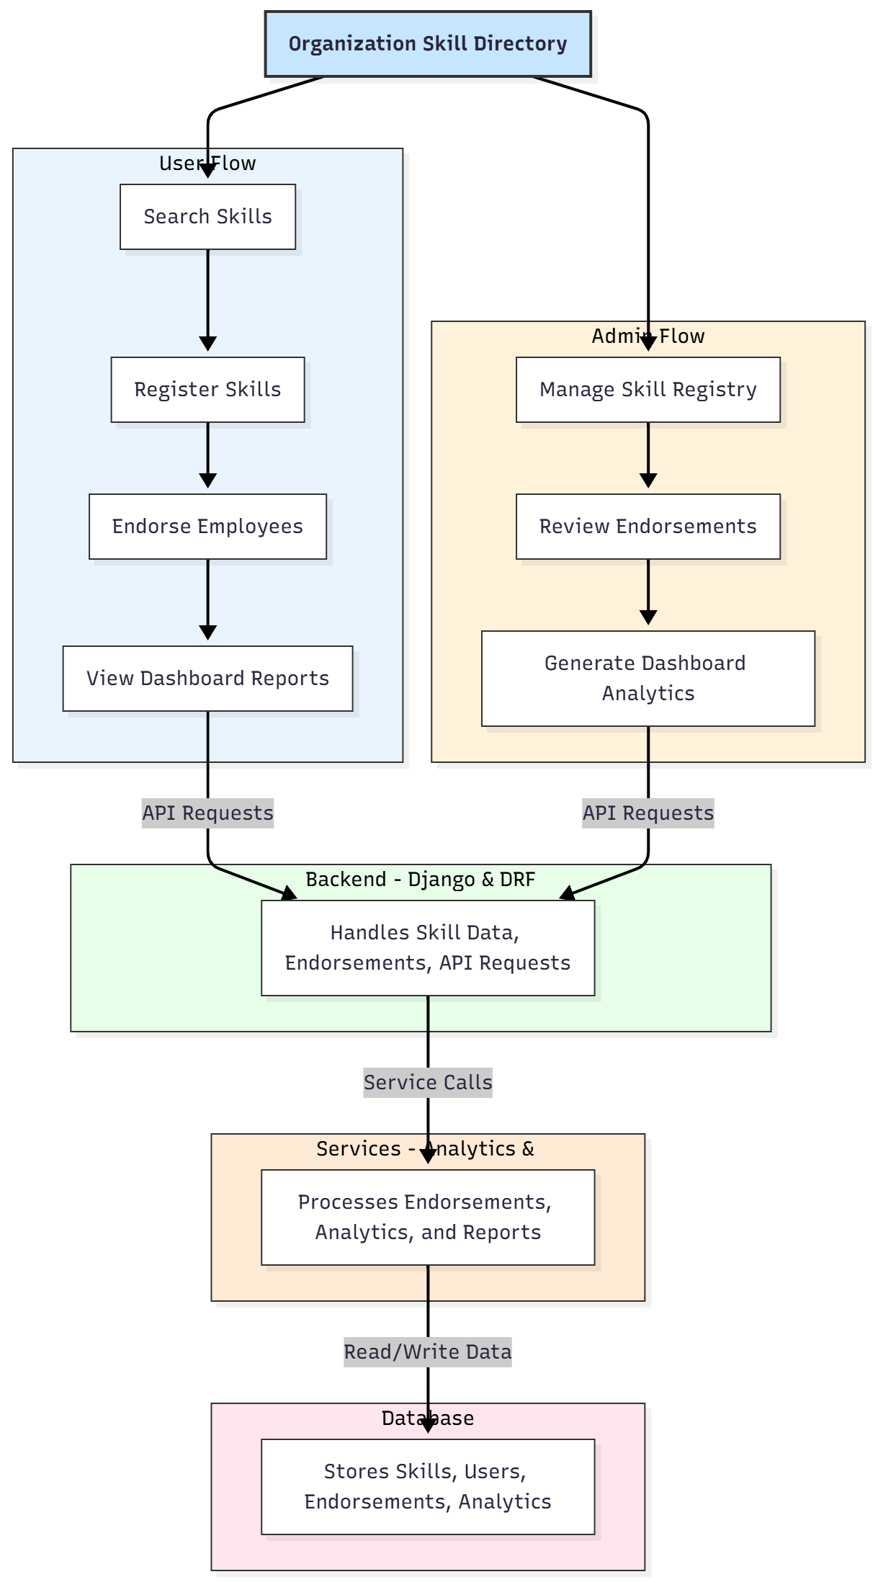

WORKING OF THE PROJECT:
Users can search for existing skills or register their own. Employees can endorse colleagues, validating their competencies. Each action is recorded in the backend, updating skill profiles and endorsement counts. Administrators manage the skill registry, review endorsements for accuracy, and monitor system usage through dashboards. The services module processes analytics for endorsements, skills distribution, and user engagement. All data is stored securely in the database, allowing real-time access, reporting, and performance tracking. This workflow ensures a reliable, transparent, and structured system for skill management..

SOFTWARE REQUIREMENT:
- Backend:
  - Python 3.x
  - Django
  - Django REST Framework
  - SQLite/PostgreSQL
- Frontend:
  - Node.js and npm
  - React.js
  - Axios
- Development Tools:
  - Visual Studio Code
  - Postman (for testing APIs)
  - Git/GitHub (for version control)
- Server/Deployment (Optional):
  - Gunicorn, Nginx, or Heroku/AWS for hosting

ADVANTAGES OF THE PROJECT:

• Centralized skill management for organizations
• Transparent endorsement system for employees
• Real-time dashboards for administrators
• Reduces manual tracking and data fragmentation
• Improves HR decision-making and workforce planning
• Encourages skill development and recognition
• Secure and scalable architecture
• Enhances overall organizational efficiency

APPLICATIONS OF THE PROJECT:
• HR departments of companies
• Schools and educational institutions
• Skill networks and professional communities
• Corporate talent management systems
• Employee training and assessment programs
• Workforce analytics and planning

REFERENCES:

- Django REST Framework Documentation — Django Software Foundation. Django Documentation. Available: https://docs.djangoproject.com/
- Django REST Framework. DRF Documentation. Available: https://www.django-rest-framework.org/
- React. React Official Documentation. Available: https://reactjs.org/docs/getting-started.html
- Redux. Redux Documentation. Available: https://redux.js.org/introduction/getting-started
- PostgreSQL Global Development Group. PostgreSQL Documentation. Available: https://www.postgresql.org/docs/
- MySQL. MySQL Reference Manual. Available: https://dev.mysql.com/doc/
- Git. Git Documentation. Available: https://git-scm.com/doc
- Node.js. Node.js Documentation. Available: https://nodejs.org/en/docs/
- Axios. Axios Documentation. Available: https://axios-http.com/docs/intro
- Socket.io Documentation – https://socket.io/docs/

